Ideation Phase
Empathize & Discover
Date | 12 October 2026
Team ID | SWUID2026403309
Project Name | Staff Sync – Modern Human Resource Management Solution
Maximum Marks | 4 Marks
Empathy Map Canvas:
Persona 1 – Employee
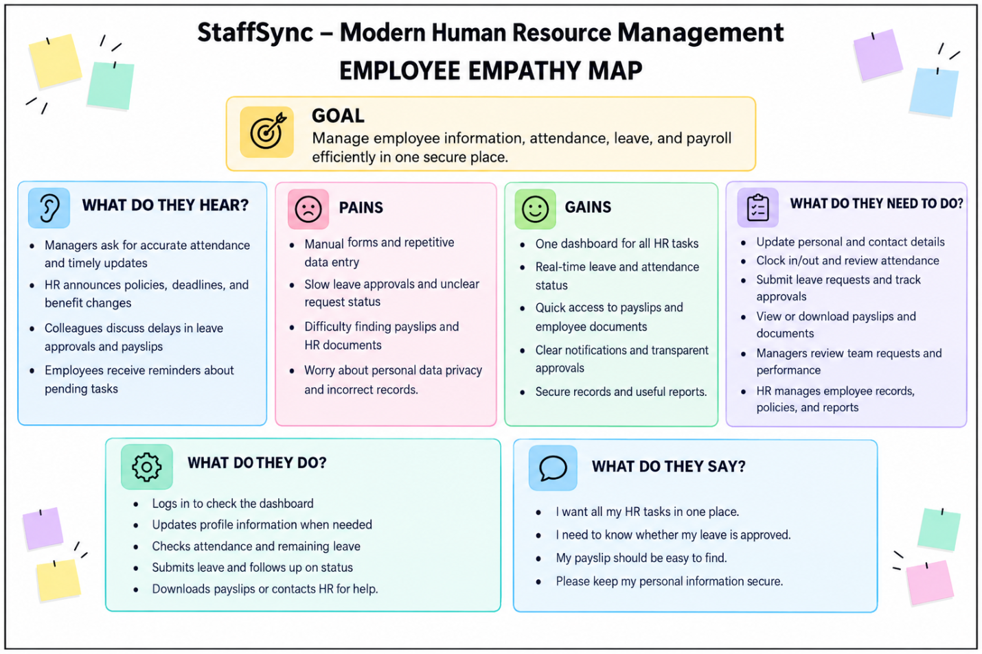
Persona 2 – Cinema HR Manager / Event Organizer / HR Administrator
Understand the needs of the people who run departments and leave and training HR events and manage the platform behind the scenes.

